Synthesis and Characterization of Luminescent Metal-Organic Frameworks for Explosives Detection

Departments of Biomedical Engineering and Chemistry

California State University, Long Beach

ENGR 361 Scientific Communication

Assignment 4: Research Paper

# Abstract

Several studies have been conducted on the creation of luminescent metal-organic frameworks (MOFs) that can be used for the trace detection of explosive compounds. However, the lower limit of the sensing mechanism of fluorescein-doped zeolitic imidazolate framework-8 (Fluorescein@ZIF-8) with nitroamines has not yet been quantified. The location of fluorescein dye particles within the ZIF-8 structure has not been clearly identified either. We hypothesized that fluorescein dye particles would be located within sodalite cages of Fluorescein@ZIF-8, and that Fluorescein@ZIF-8 would undergo a fluorescence increase in the presence of nitroamine concentrations, using a 10% v/v pyridine solution as nitromamine surrogate. The luminescent MOF in question has been shown to sense nitroaromatic explosive compounds via a fluorescence decrease8, but we observed that Fluorescein@ZIF-8 (reintroduced to aqueous solution) underwent a fluorescence increase when in the presence of the nitroamine-modelling compound pyridine. Fluorescein dye molecules were incorporated into ZIF-8 nanoparticles to synthesize a luminescent MOF via a one-pot synthesis. Infrared spectroscopy (IR), X-ray powder diffraction (XRD), and UV/Vis spectroscopy were then utilized to study the chemical composition, crystal structure, and optical absorbance of the luminescent MOF. A fluorometer was used to quantify the fluorescence increase of 3150 μL of the luminescent ZIF-8 upon the addition of 350 μL of pyridine, a chemical that models nitroamine explosives. We recorded a 47.86% increase in the fluorescence of Fluorescein@ZIF-8 after exposure to 10% v/v pyridine, but the scale of this increase was small and testing of the MOF in its solid state is needed. High alignment of the ATR-IR and PXRD spectra between regular ZIF-8 and Fluorescein@ZIF-8 showed that fluorescein particles are held within the sodalite cages of the ZIF-8 structure, rather than on surface groups or within the nanoparticle pores of ZIF-8.

# Introduction / Background

Fast and reliable detection of explosive compounds is essential for maintaining national and global security. Problems arise not only from the immediate danger to life that explosives impose but also the residues that they can leave behind in the environment3. Metal-organic frameworks (MOFs) are a class of materials that has attracted increasing attention for their multitude of uses5, one of them being explosives detection. MOFs, which are made of metal clusters linked by organic ligands, have a high porosity, adjustability, and internal surface area5. The composition makes MOFs useful for gas storage, thin films, as adsorbent materials, and more5. For use in explosives detection, MOFs can be synthesized to be luminescent (LMOFs) via the addition of guest materials. These LMOFs then change their photoemission profiles depending on what other compounds they come in contact with, which is ideal for trace detection of explosives6.

Compound detection mechanisms of LMOFs include fluorescence quenching and fluorescence enhancement. The electron affinity of the molecule to be sensed determines which sensing mechanism occurs. An analyte with the high electron affinity will quench an LMOF’s fluorescence, while an LMOF with a higher electron affinity will gain more excited electrons to enhance its fluorescence6. This is how an LMOF can selectively detect explosives—some explosive compounds will cause a fluorescence increase and others will cause a decrease. However, most research on LMOF explosive involves fluorescence quenching, which seems to be the more common out of the two mechanisms.

Zeolitic Imidazolate Framework-8 (ZIF-8) was selected as a base MOF for explosives detection because of its thermal and aquatic stability8. Fluorescein dye was selected as the luminescent guest compound for its commercial availability and wide use as a biological chemosensor4. ZIF-8 has been effectively used as a chemosensor in the aqueous and vapor phases7. Zhang *et al.*4 conducted a study on the use of ZIF-8 with Rhodamine B dye and fluorescein dye derivatives to sense nitrofurans and tetracyclines (types of antibiotics) in water. Fluorescence quenching and enhancement occurred on the LMOF, respectively, with very low limits of detecting ranging from 0.16 μM to 0.47 μM4. Another study led by Prathap *et al.*8 involved the detection of TNT and other nitroaromatic explosive compounds using ZIF-8, via a reduction of the analytes and a fluorescence quenching of ZIF-8. The lower limit of TNT detection was 346 pM. Other fluorescein derivatives have also been used for TNT detection3; however, there have not been studies on the use of luminescent ZIF-8 to sense nitroamine explosives.

Additionally, no studies exist verifying the mechanism by which fluorescein bonds to ZIF-8; there is a possibility that the dye particles bond to open surface groups on the ZIF-8 surface, enter the pores of the ZIF-8 crystal structure, or are within the sodalite structure of the ZIF-8. When fluorescein is added to ZIF-8, a possible reason for maintained fluorescence in the solid state is “restriction of intramolecular rotation” of the fluorescein particles1, which is more likely to occur if fluorescein is encapsulated within the sodalite cages of ZIF-8. This could be confirmed using chemical characterization techniques, such as UV/Vis Spectroscopy, Attenuated Total Reflectance Infrared Spectroscopy (ATR-IR), and Powder X-Ray Diffraction (PXRD). These are common forms of spectroscopy that are used to determine the chemical composition, crystal structure, and peak absorbance wavelength of compounds, respectively.

In this study we aim to successfully synthesize a luminescent metal-organic framework (Fluorescein@ZIF-8), use chemical characterization techniques to determine where in/on the ZIF-8 structure fluorescein dye particles have attached, and measure the fluorescence increase that occurs when Fluorescein@ZIF-8 contacts the nitroamine-modelling compound pyridine. We hypothesize that fluorescein dye particles are located within the sodalite cages of Fluorescein@ZIF-8, and that the MOF will undergo a fluorescence increase in the presence of nitroamine-containing solution because of nitroamines’ tendency to act as electron-donating groups. This is for the future goal of further quantifying ZIF-8’s explosive detection abilities and validating Fluorescein@ZIF-8’s use as a selective explosive-detecting compound for nitroamines and nitroaromatics.

# Methods

**Chemicals**

Chemicals used were reagent grade and sourced from Fisher Chemical. Zinc nitrate hexahydrate, 2-methylimidazole, methanol, and 200 proof ethanol were used to synthesize ZIF-8. Fluorescein dye powder was used to synthesize Fluorescein@ZIF-8. Aqueous pyridine was used as explosive-modelling compound with which Fluorescein@ZIF-8 was tested.

**Equipment**

UV/Vis Spectroscopy spectra were collected with a Shimadzu UV-1800 UV spectrophotometer (Shimadzu Scientific Instruments, Carlsbad, California). ATR-IR spectra were collected with a Bruker Alpha spectrometer (Bruker Optics Inc., Billerica, Massachusetts). PXRD spectra were collected with a PANalytical X’pert Pro X-ray diffractometer (Malvern Panalytical Ltd., Malvern, United Kingdom). Fluorescence spectra were collected with a Shimadzu RF-5301 spectrofluorometer (Shimadzu Scientific Instruments, Carlsbad, California).

**Data**

Spectra from the listed characterization techniques were collected. Peaks of the ATR-IR, PXRD, and UV-Vis spectra for Fluorescein@ZIF-8 were compared to that of regular ZIF-8 and fluorescein. Fluorescence spectra were used to quantify the fluorescence increase that Fluorescein@ZIF-8 underwent in the presence of pyridine.

**Protocol**

ZIF-8 was first synthesized by dissolving 0.733 grams of zinc nitrate hexahydrate and 1.622 grams of 2-methylimidazole in separate beakers of 50 mL of methanol. The zinc nitrate hexahydrate solution was added to the 2-methyimidazole, and the solution was stirred for one hour to allow formation of ZIF-8 nanocrystals. The ZIF-8 solution was then centrifuged in an Eppendorf 5340 Centrifuge at 7500 RPM to separate the nanoparticles from the methanol. The nanoparticles were introduced to ethanol and centrifuged twice more before drying for 24 hours in a gravity convection oven at 100 °C. The protocol for synthesizing Fluorescein@ZIF-8 remained the same, save for an addition of 5 mg of fluorescein powder dissolved in 50 mL of methanol to the solution before mixing. Following synthesis of the nanocrystals, spectra were obtained using the previously mentioned instruments and small samples (0.05 g) of the MOF and LMOF powders. For fluorescence testing, 350 μL of pure pyridine and 350 μL of 10% v/v pyridine in ethanol was pipetted into 3150 μL of 0.5 ppm fluorescein in ethanol. 350 μL of pure pyridine was then pipetted into 3150 μL of 57.895 ppm Fluorescein@ZIF-8 in deionized water. All spectra were obtained as numerical points which were then graphed in Excel.

**Data Analysis**

UV/Vis spectra were used to compare the peak absorbance wavelength of Fluorescein@ZIF-8 against that of fluorescein in liquid and solid phase. ATR-IR spectra were used to compare the surface chemical composition of the two different nanocrystal types, while PXRD was used to compare their crystalline structure. Fluorescence spectra were used to quantify the increase of fluorescence in Fluorescein@ZIF-8 when in contact with pyridine, the explosive-modelling compound.

# Results

UV-Vis spectra indicated that solid Fluorescein@ZIF-8 exhibited the same peak absorbance as fluorescein in aqueous form. PXRD and ATR-IR spectra of Fluorescein@ZIF-8 and regular ZIF-8 showed complete alignment. Following the addition of 350 μL of 10% v/v pyridine, the fluorescence intensity of 3150 μL of 0.5 ppm fluorescein alone jumped from 117.122 to 606.088 for a 417.49% increase, shown in Figure 5a. The fluorescence intensity of 3150 μL of Fluorescein@ZIF-8 (containing 0.5 ppm of fluorescein doped inside) started out much smaller at 3.991, with a small jump to 5.901 after the addition of 350 μL of 10% v/v pyridine for an increase of 47.86%, shown in Figure 5b.

**Figure 1: Fluorescein@ZIF-8 Synthesis**

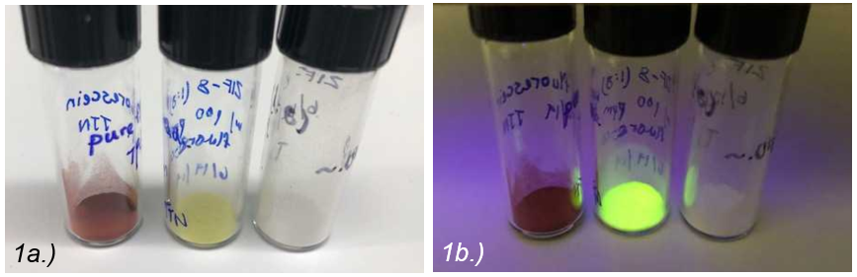

Depicted are images of solid fluorescein dye powder, Fluorescein@ZIF-8 nanocrystals, and ZIF-8 nanocrystals under fluorescent lights (1a) and UV light (1b). Under UV light, Fluorescein@ZIF-8 maintains the fluorescent quality of fluorescein in aqueous form.

**Figure 2: UV/Vis spectroscopy**

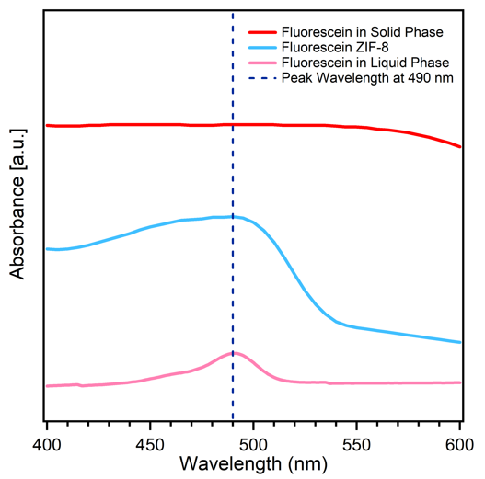

UV/Vis spectra are presented for solid Fluourescein@ZIF-8 and fluorescein dye in solid and liquid phase. Solid Fluorescein@ZIF-8 and fluorescein in aqueous phase have a peak absorbance wavelength of 490 nm.

**Figure 3: ATR-IR spectroscopy**

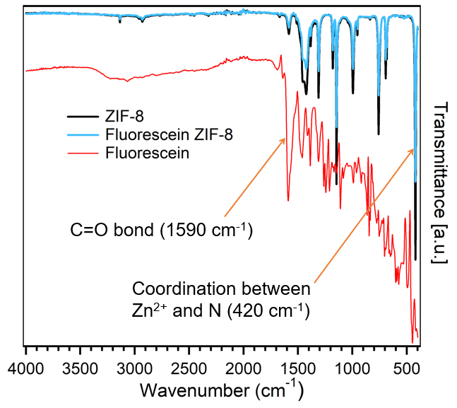

ATR-IR spectra are presented for solid ZIF-8, solid Fluorescein@ZIF-8, and solid fluorescein. High peak alignment is present between Fluorescein@ZIF-8 and ZIF-8.

**Figure 4: PXRD**

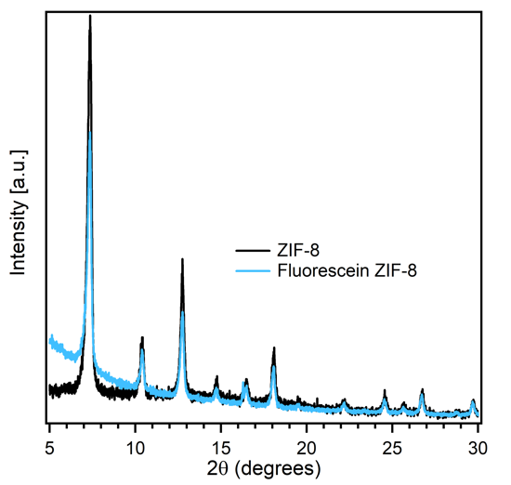

PXRD spectra are presented for solid ZIF-8 and solid Fluorescein@ZIF-8. High peak alignment is present between Fluorescein@ZIF-8 and ZIF-8.

**Figure 5: Fluorescence spectroscopy**

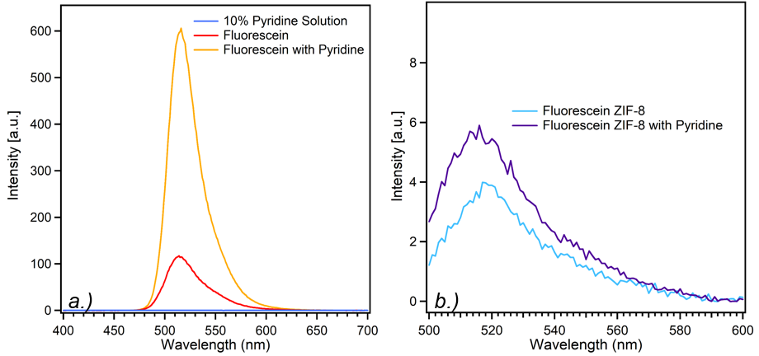

Fluorescence spectra are presented for (a) aqueous 0.5 ppm fluorescein, fluorescein with 10% v/v pyridine solution, and fluorescein with pure pyridine, and (b) aqueous 57.895 ppm Fluorescein@ZIF-8 with and without pure pyridine. Fluorescence increased by 417.49% and 47.86%, respectively.

# Discussion

Several chemical characterization techniques were used to determine the binding mechanism of fluorescein dye to the nanocrystal structure of ZIF-8. We hypothesized that fluorescein dye particles were located in the sodalite structure of the ZIF-8 nanoparticles, rather than the pores of the structure or the open surface groups. The characterization techniques used provided data suggesting that fluorescein dye particles were indeed within the sodalite structure of the ZIF-8 nanoparticles.

Upon synthesizing solid Fluorescein@ZIF-8, the fluorescent quality of fluorescein under UV light, usually only present in aqueous and not solid fluorescein, was maintained. Figure 2 shows that solid Fluorescein@ZIF-8 and aqueous fluorescein have the same peak absorbance wavelength of 490 nm and thus have the same fluorescent property. This peak wavelength is present for solid fluorescein. As stated, this could be explained aggregation-induced emission (AIE). Fluorescein molecules would have to be intramolecularly restricted for the observed fluorescence to occur in the solid state, and this would be more likely to occur if fluorescein particles were located within the ZIF-8 rather than on ZIF-8’s open surface groups.

Resulting ATR-IR spectra depicts both ZIF-8 and Fluorescein@ZIF-8 with identical IR peaks (Figure 3). This includes the peak at 420 cm-1, which is a wavelength used to identify the presence of a coordination bond between zinc and nitrogen and thus confirms the presence of ZIF-8. As IR has a penetration of a few microns, the identical graphs show that the surface chemical composition of ZIF-8 and fluorescein ZIF-8 are the same. A carbonyl peak at 1590 cm-1 is present on fluorescein but not on fluorescein ZIF-8, showing that fluorescein is not present on the Fluorescein@ZIF-8 surface and is therefore not bound via open surface groups.

PXRD spectra also depicts identical peaks between ZIF-8 and fluorescein ZIF-8 (Figure 4). This shows that the crystal structures of ZIF-8 and Fluorescein ZIF-8 are the same. If fluorescein dye particles had entered ZIF-8 nanoparticle pores, peaks of the XRD spectra would shift due to a disturbance in the crystal structure of Fluorescein@ZIF-8 during formation. Therefore, these identical spectra are indicative of fluorescein dye not being present within the pores of the ZIF-8 structure.

Figure 5 depicts the fluorescence increase that fluorescein and Fluorescein@ZIF-8, both in aqueous phase, undergo in the presence of pyridine. This fluorescence-increasing mechanism occurs due to pyridine becoming an electron donor in the presence of fluorescein, thus allowing for detection of pyridine. Fluorescein alone underwent a much greater fluorescence increase than Fluorescein@ZIF-8, the latter compound having an increase that was hardly detectable. This was expected since Fluorescein@ZIF-8 was synthesized as solid nanoparticles; currently we are testing the fluorescence increase of Fluorescein@ZIF-8 in the solid state.

With the current data obtained from characterization techniques, fluorescein binding to the open surface groups or being within the pores of Fluorescein@ZIF-8 can be ruled out. We can then assume that fluorescein dye particles are located within the sodalite structure of ZIF-8. In the future we plan to further study the encapsulation mechanism of fluorescein in ZIF-8 using transmission electron microscopy (TEM). However, we face limitations in that these techniques are not so readily available. Additionally, further testing of Fluorescein@ZIF-8 with lower concentrations of aqueous pyridine is needed. Our study faced limitations in that multiple trials were not run—since characterization spectra are assumed to be consistent for a substance, several trials are usually not needed, but they could be run in the future to confirm accuracy of spectra alignment. Testing of Fluorescein@ZIF-8 in the solid state rather than the aqueous state is also needed, but this is restricted by a lack of available instruments to quantitatively measure fluorescence increase in solids. Once chemical characterization is further completed, we plan for the optimization of Fluorescein@ZIF-8 as a nitroamine detector, which can be achieved via functionalization or change in methods of material administering.

# Conclusion

A luminescent MOF was successfully synthesized by incorporating fluorescein dye particles into zeolitic imidazolate framework-8 nanoparticles. Analytical techniques of ATR-IR, XRD, and UV/Vis spectroscopy suggested that the fluorescein was encapsulated by the sodalite structure of ZIF-8, rather than being adsorbed on the surface or in the pores of the crystal cells. The resulting Fluorescein@ZIF-8 retained fluorescent properties of fluorescein that are only present in liquid phase due to aggregation-induced emission. However, the fluorescence increase of the fluorescein-ZIF-8 upon the addition of pyridine was minimal compared to that of fluorescein alone, likely due to the encapsulation of the fluorescein particles. Use of further characterization techniques like TEM and testing of Fluorescein@ZIF-8 in the solid state are anticipated.

# References*.*

(1) Hong, Y.; Lam, J. W. Y.; Tang, B. Z. Aggregation-Induced Emission. Chem. Soc. Rev. 2011, 40 (11), 5361–5388. <https://doi.org/10.1039/C1CS15113D>.

(2) Chaudhari, A. K.; Tan, J.-C. Dual-Guest Functionalised ZIF-8 Framework for 3D Printing White Light-Emitting Composites. arXiv:1910.02031 [cond-mat, physics:physics] 2019.

(3) Sun, X.; Wang, Y.; Lei, Y. Fluorescence Based Explosive Detection: From Mechanisms to Sensory Materials. Chem. Soc. Rev. 2015, 44 (22), 8019–8061. <https://doi.org/10.1039/C5CS00496A>.

(4) Zhang, Y.-Q.; Wu, X.-H.; Mao, S.; Tao, W.-Q.; Li, Z. Highly Luminescent Sensing for Nitrofurans and Tetracyclines in Water Based on Zeolitic Imidazolate Framework-8 Incorporated with Dyes. Talanta 2019, 204, 344–352. <https://doi.org/10.1016/j.talanta.2019.06.019>.

(5) Zhou, H.-C.; Long, J. R.; Yaghi, O. M. Introduction to Metal–Organic Frameworks. Chem. Rev. 2012, 112 (2), 673–674. <https://doi.org/10.1021/cr300014x>.

(6) Hu, Z.; Deibert, B. J.; Li, J. Luminescent Metal–Organic Frameworks for Chemical Sensing and Explosive Detection. Chem. Soc. Rev. 2014, 43 (16), 5815–5840. <https://doi.org/10.1039/C4CS00010B>.

(7) Lu, G.; Hupp, J. T. Metal−Organic Frameworks as Sensors: A ZIF-8 Based Fabry−Pérot Device as a Selective Sensor for Chemical Vapors and Gases. J. Am. Chem. Soc. 2010, 132 (23), 7832–7833. <https://doi.org/10.1021/ja101415b>.

(8) Prathap, M. U. A.; Gunasekaran, S. Rapid and Scalable Synthesis of Zeolitic Imidazole Framework (ZIF-8) and Its Use for the Detection of Trace Levels of Nitroaromatic Explosives. Adv. Sustainable Syst. 2018, 2 (10), 1800053. <https://doi.org/10.1002/adsu.201800053>.

# Figures

**Figure 1: Fluorescein@ZIF-8 Synthesis**

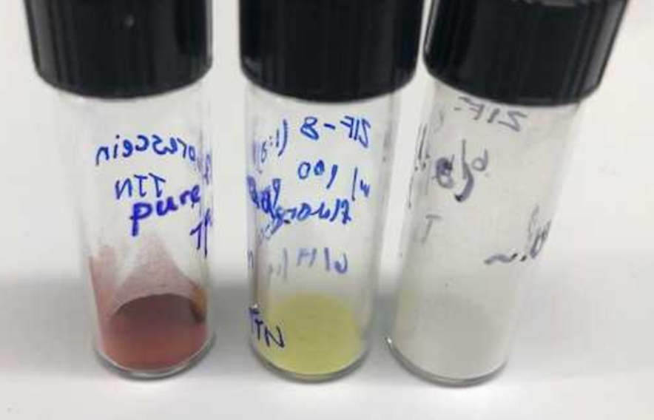

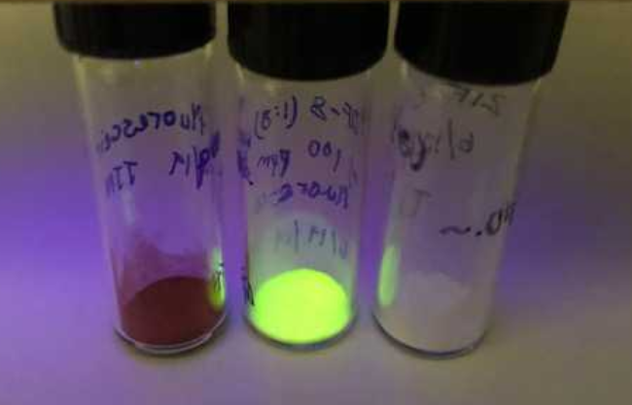

**Figure 2: UV/Vis spectroscopy**

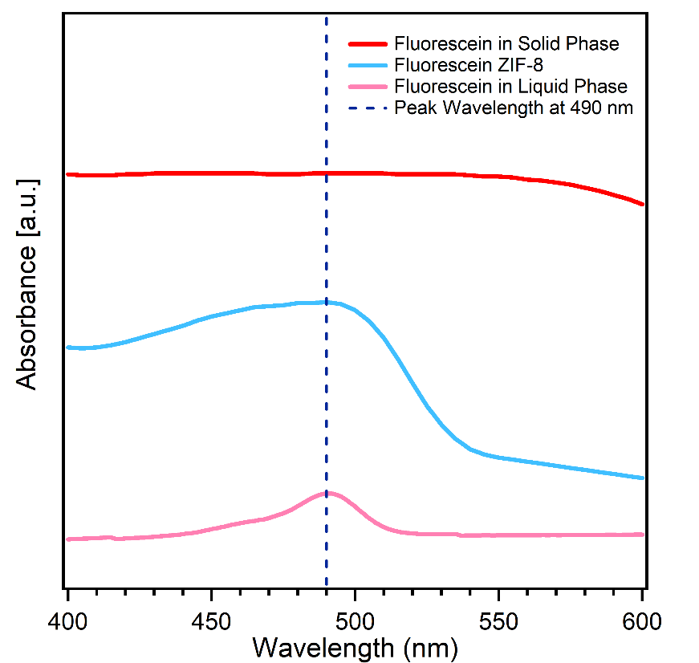

**Figure 3: ATR-IR spectroscopy**

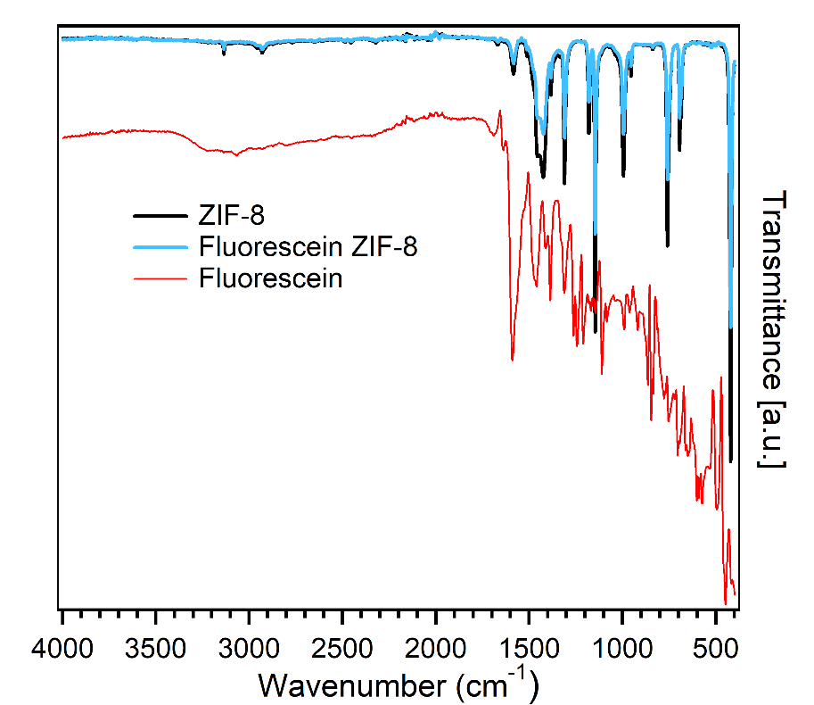

**Figure 4: PXRD**

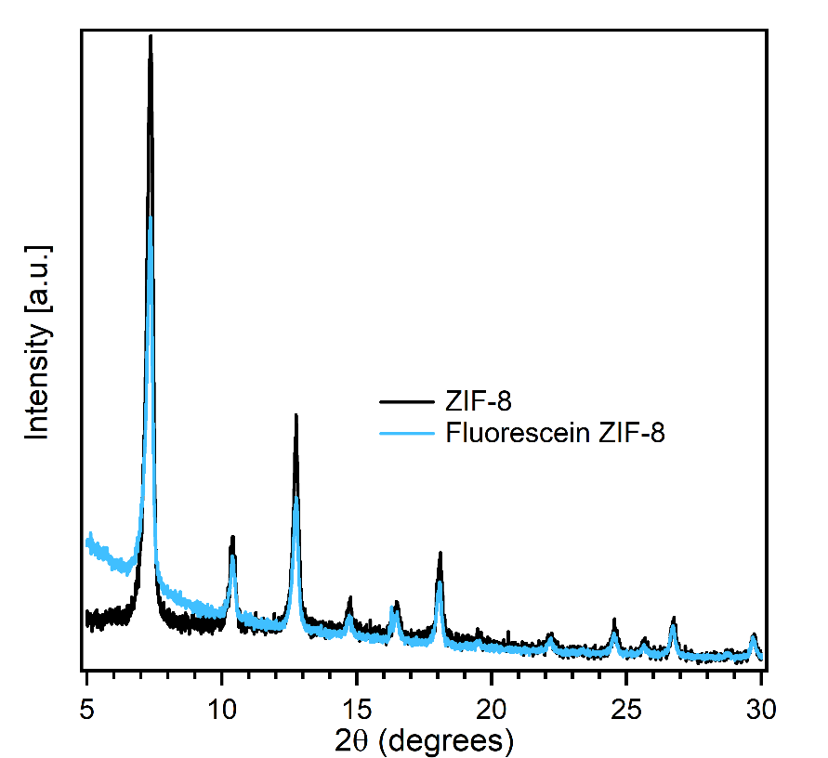

**Figure 5: Fluorescence spectroscopy**

